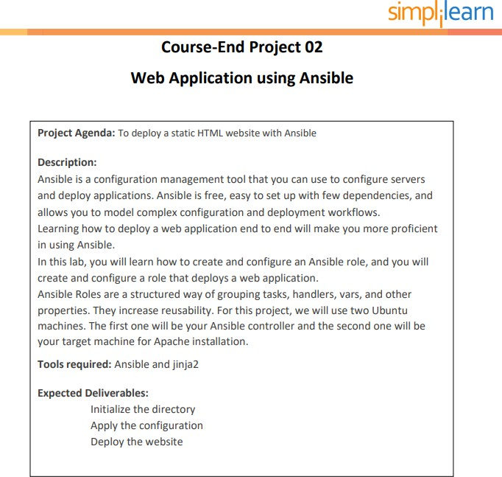

Solution:

**Repository link: https://github.com/haelkh/project3.git**

Sudo su -

cd /etc/ansible/roles

ansible-galaxy init projectAnsible cd projectAnsible

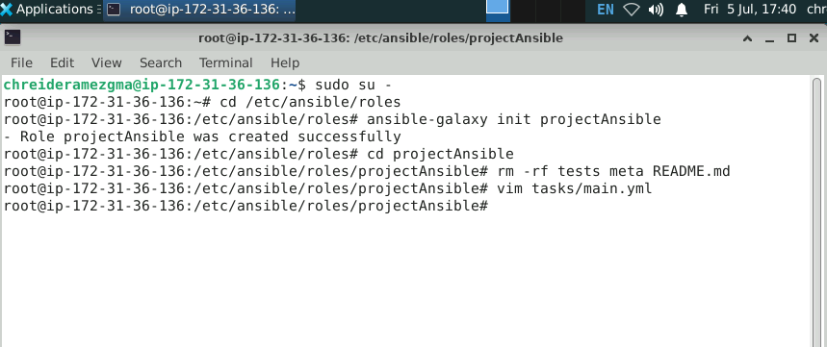rm -rf tests meta README.md

vim tasks/main.yml

=====================================================

'#' Tasks file for projectAnsible

* name: Display the hostname command: hostname -s

notify: Print command message

* name: Install Apache on webserver package:

name: "{{ pkg_name }}"

state: "{{ pkg_state }}"

* name: Start Apache server

service:

name: "{{ pkg_name }}" state: started

* name: Deploy HTML page on Apache template:

src: index.html.j2

dest: /var/www/html/index.html notify: Restart the Apache server

Save the file

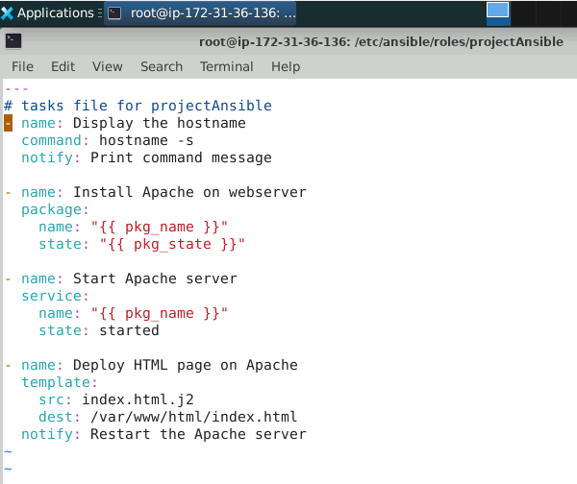

=====================================================

vim handlers/main.yml

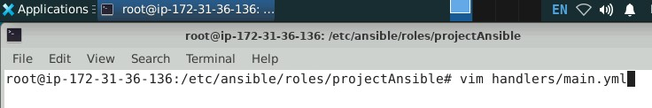

'#' handlers file for projectAnsible

* name: Restart the Apache server service:

name: "{{ pkg_name }}" state: restarted

* name: Print command message debug:

msg: "Command executed successfully"

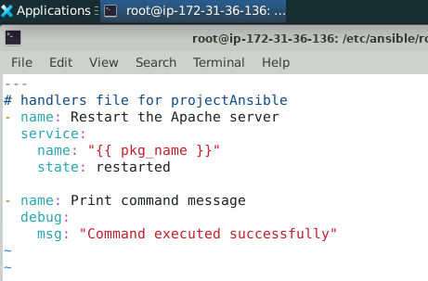

Save the file

=====================================================

'#' vim vars/main.yml

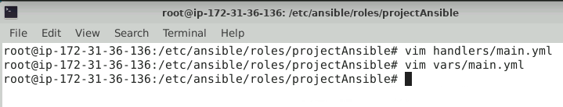

pkg_name: apache2 pkg_state: present

save the file

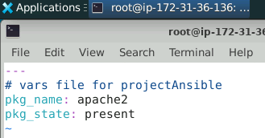

=====================================================

'#' vim templates/index.html.j2

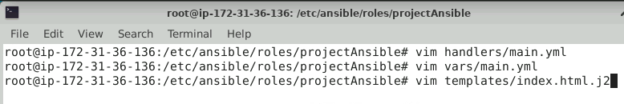

This file is for web application.

It is deployed on server {{ ansible_nodename }}.

IP address of the Host: {{ ansible_default_ipv4.address }}. Host Node Name: {{ ansible_nodename }}.

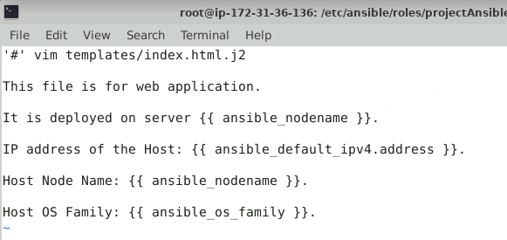Host OS Family: {{ ansible_os_family }}. save the file

===================================================== '#' cd ../..

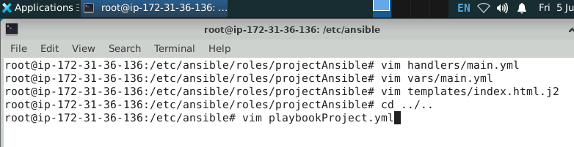You will be in the /etc/ansible directory now. '#' vim playbookProject.yml

---

* name: Execute projectAnsible role hosts: webserver

become: true roles:

- projectAnsible

'#' ansible-playbook playbookProject.yml

